Instructions for accessing engineering software remotely

Faculty and students may need access to some engineering software when they are not on campus. Some of our engineering applications are available to be downloaded and installed on your personal computers. However, some of the software cannot be installed on remote computers due to the licensing agreement, so users must remotely login to one of our computers in the engineering labs and use the software remotely.

This file gives instructions for accessing several engineering software applications whether by downloading and installing them directly or by remotely logging into one of the engineering computers. The list of software includes SolidWorks, Matlab, Labview, Multisim, Ultiboard, Microstation, STAAD, Open Roads, and Engineering Equation Solver.

Please note, to run SolidWorks, Adams, or Autodesk software while your PC is connected to the Harding network, the PC must be physically connected by an ethernet cable. To use these applications with a PC that is not physical connected via an ethernet cable to the Harding network, Harding’s Cisco VPN software must be running and connected. The other software in this document is licensed directly by the vendor using a serial number, or access is obtained through your course instructor.

Please contact Wes Plybon, [hplybon@harding.edu](mailto:hplybon@harding.edu) or 501-279-5405, if you need access to any other software nor listed here.

**Instructions for downloading and installing the Cisco VPN software**

In most instances, you must be running a secure VPN software client to install software licensed to Harding, to run software licensed to Harding, or to remotely login to a Harding computer. The instructions for installing the Cisco VPN software are listed at the end of this document. Only the link is given here and the software can only be access from the web, not from Harding’s network.

To download and get further instructions go to [https://Searcy-fpr.harding.edu](https://searcy-fpr.harding.edu)

**Remote login to a Harding computer**

In some cases, you may be able to install and run our engineering software on your own computer, but another way to access the software is to remotely login to a computer in one of our engineering labs and run the software remotely. While there are no live classes conducted on campus, all of the classroom PCs will be available for remote login. Below is a list of the PC names for each room. The room number is in the name, followed by the number for the PC in that room. To use remote login on a Macintosh PC running Mac OS, you must install the Microsoft Remote Desktop Client available at the Mac App Store.

List of engineering computer names, where “xx” is a range of numbers in parentheses:

PE-214L-xx (01 thru 12) PE-220L-xx (01 thru 17) PE-303L-xx (01 thru 24)

PE-306-xx (01 thru 08) PE-307-xx (01 thru 10) PE-313-xx (01 thru 24)

*Steps to remote login to a Harding engineering lab computer on a Windows PC*

1. Select the Windows Icon and type Remote Desktop Connection.

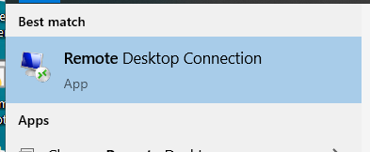

1. The Remote Desktop Connection app should open. In the dialogue box enter one of the computer names reserved for remote connection followed by Harding’s network domain name. As an example, you may type in PE-303L-02.harding.edu to access computer 2 in SCI 303.

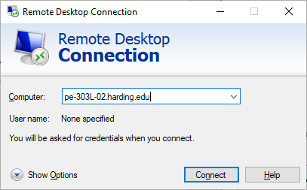

1. A new Windows Security window should open asking for your username and password. Add harding.edu\ before your Harding username in the username field. Type in your Harding account password in the password field and then select OK. As an example, Joe Student's username was joestudent, he would type harding.edu\joestudent as his username.

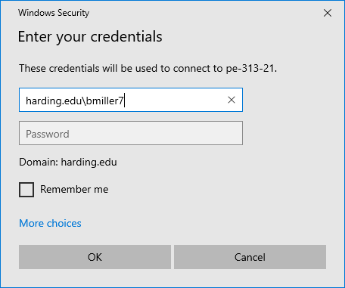

1. If another remote student is already logged into the computer, you'll get a message with that information. In that case, choose another computer to access. Please limit your time on the computers as others will need to access them for their assignments. When you are ready to end the use of the remote PC, please sign out of that remote PC the same way you typically sign out. If the “X” icon in the upper right corner is used it only terminates the connection and doesn’t terminate the remote session on the classroom PC. This can cause problems for others wishing to use that PC.

*Steps to remote login to a Harding engineering lab computer on a Mac*

Students will also need to install the Remote Desktop client for Mac available at this link.

<https://docs.microsoft.com/en-us/windows-server/remote/remote-desktop-services/clients/remote-desktop-mac>

Once the application is installed, please follow the instructions for remote login using a Windows PC.

How to get access to engineering software

**SolidWorks** – SolidWorks can be accessed by remote login to an engineering lab computer, or you may download and install it on your personal computer. Harding has a limited number of licenses for students for the full version of the software (the Student Engineering Kit or SEK version). The SEK version of the software can perform finite element analysis and other simulations. Only students that are taking classes that require Solidworks will be given a serial number to the SEK version. All other students should use classroom PCs or download the limited version (the Student Design Kit or SDK version). The SDK version of the software cannot be used to perform finite element analysis or other simulations; it can be used primarily perform 3D solid modeling. To obtain a student serial number on campus for the SEK version, please see Wes Plybon in PE-218 after the setup program is downloaded. Students that are not currently living in Searcy can email [hplybon@harding.edu](mailto:hplybon@harding.edu), agree to the confidentiality statement, and receive it by email.

*How to run SolidWorks remotely on a Harding-owned lab computer*

Download the Cisco VPN software (details were given earlier in this document)

Remote login to a lab computer and run the software (details were given earlier in this document)

*How to download and install the SEK version of SolidWorks on my own computer*

Uninstall any/all previous version of Solidworks and go to [www.solidworks.com/SEK](http://www.solidworks.com/SEK).

Enter your contact information and select ‘Yes’ to having a 9020 serial number.

Choose ‘2020-2021’ for the desired version of Solidworks, then press download.

Accept the terms of the Use Agreement and press Download.

Run the SolidworksSetup program and step through using the defaults.

At this point the serial number needs to be entered and the software will finish the installation. Students living in Searcy will need to see Mr. Plybon to have him enter the serial number. Students residing outside of Searcy should email Mr. Plybon to receive the serial number.

Mac users will have to remote into a classroom PC in the Engineering Department to use Solidworks.

There is also a basic version of Solidworks that is unlimited in number and available to any student of the university. It is called the Student Standard (SDK) and can be installed as follows:

Uninstall any/all previous version of Solidworks and go to [www.solidworks.com/SDK](http://www.solidworks.com/SDK).

Use SDK-ID=**9SDK2020** and choose 2020-2021 version.

After accepting the terms, the 24-character serial number will be displayed. Make note of this number; it is required during the installation.

Follow all remaining instructions and accept all defaults to finish the installation.

The Student Standard version does not allow finite element analysis.

**Matlab** – Matlab can be accessed by remote login to an engineering lab computer. Due to permission conflicts it is not possible to install this software on student PCs.

**National Instruments Labview, Multisim, or Ultiboard** – This software can be accessed by remote login to an engineering lab computer, or you may download and install it on your personal computer.

*How to download and install Labview, Multisim, and Ultiboard*

* To install National Instruments Labview, Multisim or Ultiboard use the links below to download. When you create your NI account, you will also need to register the serial numbers you plan to use. The NI document, [How Can I Add a Serial Number to My NI User Account?](https://knowledge.ni.com/KnowledgeArticleDetails?id=kA00Z0000004ATQSA2&l=en-US), explains how.

<https://www.ni.com/en-us/shop/labview.html>

<https://www.ni.com/en-us/support/downloads/software-products/download.circuit-design-suite.html#305920>

Once the software is downloaded, step through the installation using the defaults. When it asks for a serial number enter the following: Labview use M85X27549, Circuit Design use M85X18921.

If the student needs the Harding parts database with Circuit Design, the VPN must be running and the student will need to go to the Global Options on the Options menu and change the corporate database path to:

\\PE-HPLYBON.harding.edu\PartsDatabase\CPCOMP_S.PRJ

That path is for both Multisim and Ultiboard.

* While LabVIEW, Multisim and Ultiboard will run on MacOS, DAQmx and ELVISmx will not. This limits the use of the ELVIS station.

**Microstation, STAAD, and Open Roads** - This software can be accessed by remote login to an engineering lab computer, or you may download and install it on your personal computer.

*How to download and install Microstation, STAAD, and Open Roads*

Students using Microstation, STAAD and Open Roads will need to gain access to our Bentley Systems account from your professor and go to the following web site and login. <https://www.bentley.com/en/support>

Once the student is logged in, search for the software to download and install. Use the defaults to finish the installation. Bentleys Connect Client will also be installed.

**Engineering Equation Solver** - Students wishing to use Engineering Equation Solver must remote login to a PC in an engineering lab.

If anyone has difficulty, please contact Wes Plybon, [hplybon@harding.edu](mailto:hplybon@harding.edu) or 501-279-5405.

Instructions for Installing the Cisco VPN

Installing and running a secure VPN on your local computer allows you to access some engineering software applications on your own personal computer.

1. To download the software, in a web browser, go to [https://Searcy-fpr.harding.edu](https://searcy-fpr.harding.edu)

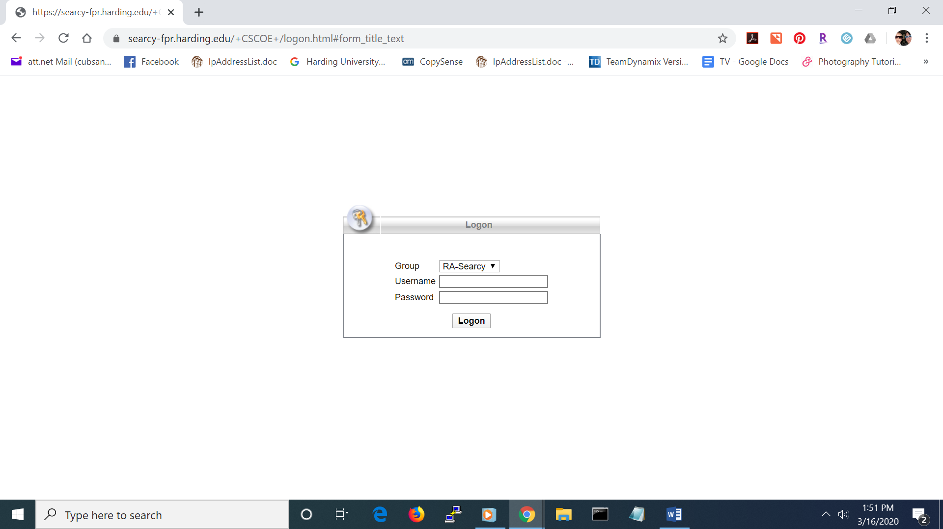

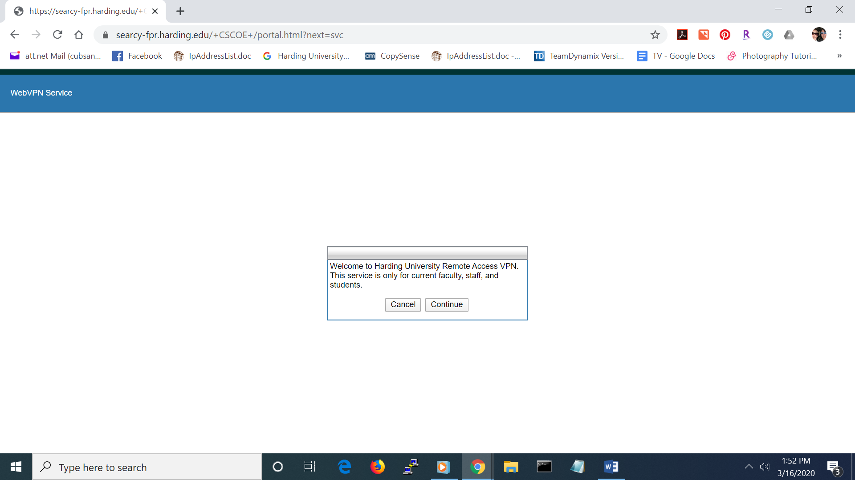2. Enter your Harding username and password in the dialogue box and select Logon. You should see the following window.

3. Click Continue

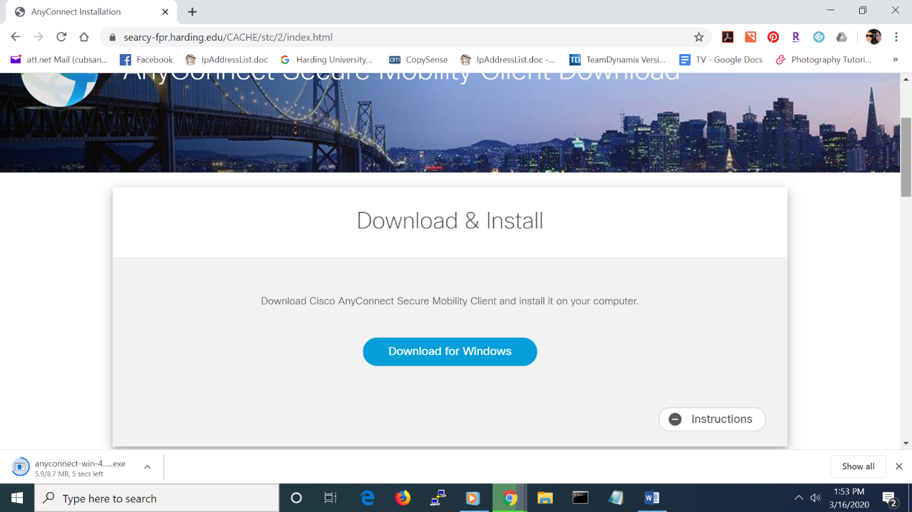

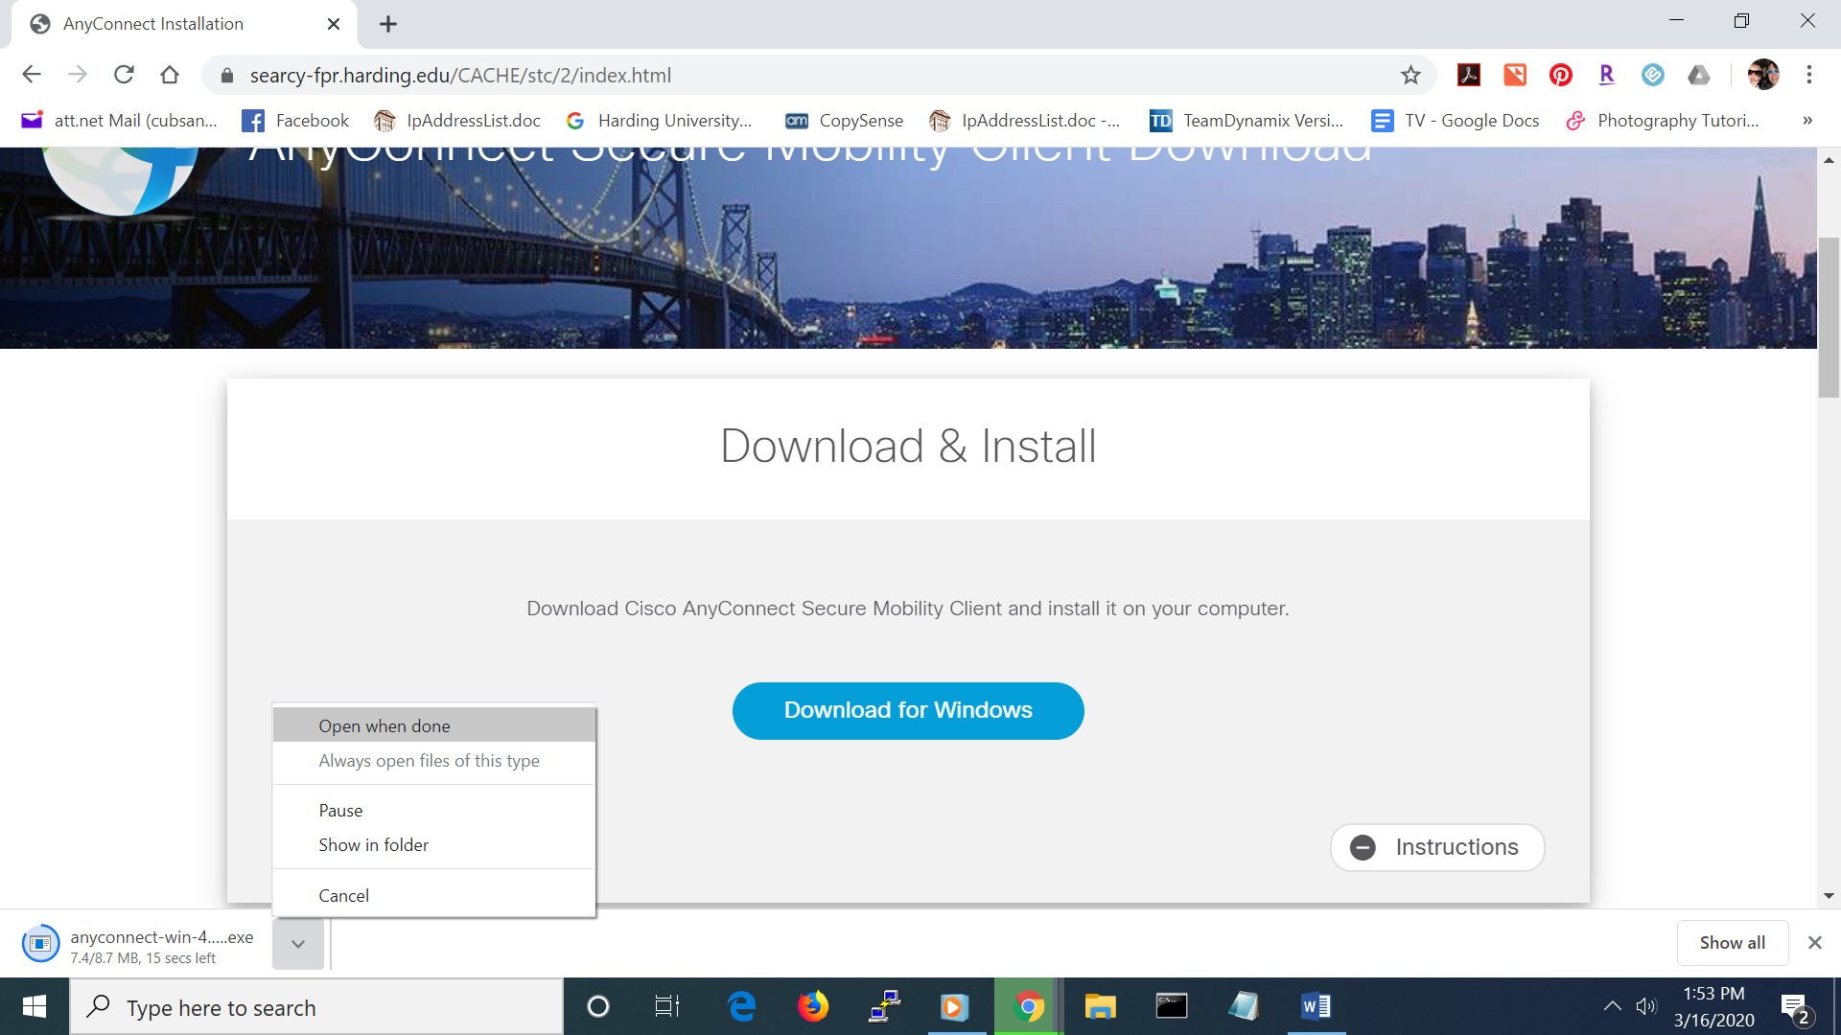4. Click Download for Windows or Mac, whichever system you are on. Select "Open when done" when the next dialogue window appears.

5. Open the installation file when it finishes downloading. You may select to expand the Instructions button for installation instructions.

6. After the installation is complete, open Cisco AnyConnect Secure Mobility Client. The following dialogue window should open.

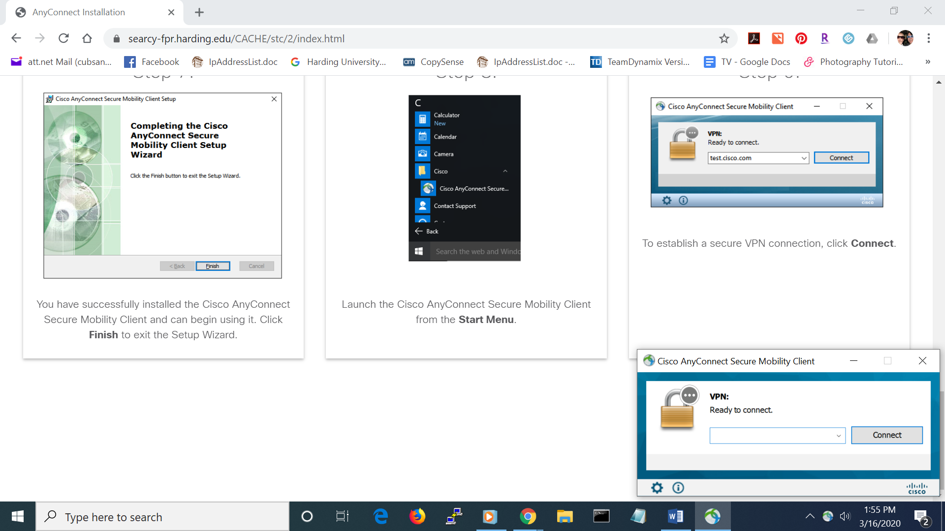

Searcy-fpr.harding.edu

7. Enter Searcy-fpr.harding.edu in the text box and click Connect. Another dialogue box should appear.

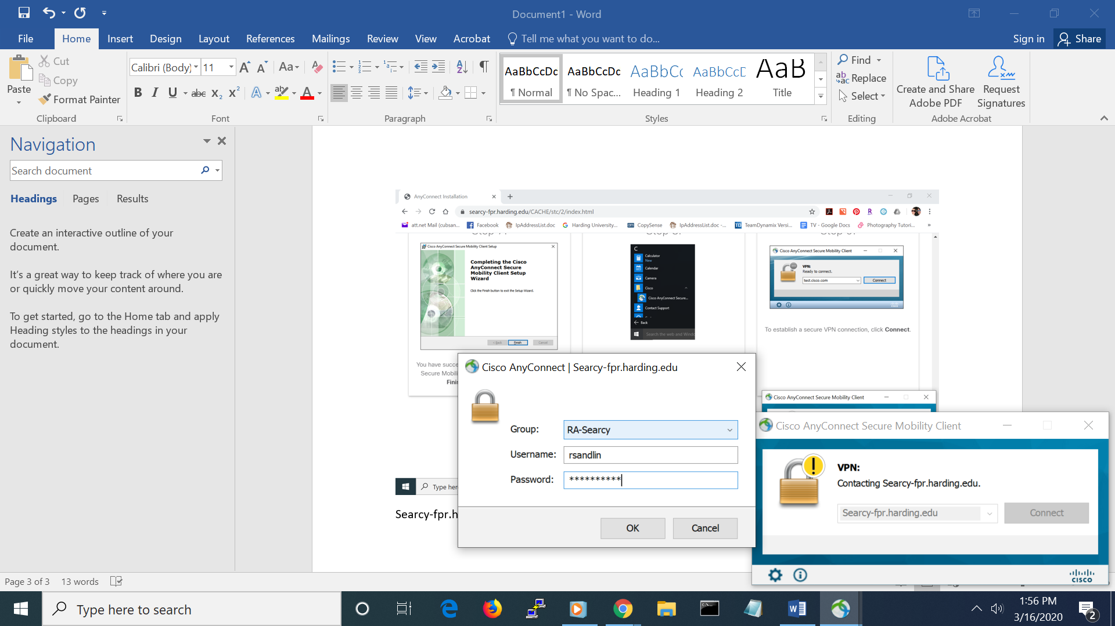

8. Enter your Harding username and password and click OK. Group will default to RA-Searcy. Another dialogue window should appear welcoming you to the Harding University Remote Access VPN. The VPN client should only be used by current Harding faculty, staff, and students. Access credentials should never be shared with anyone else.

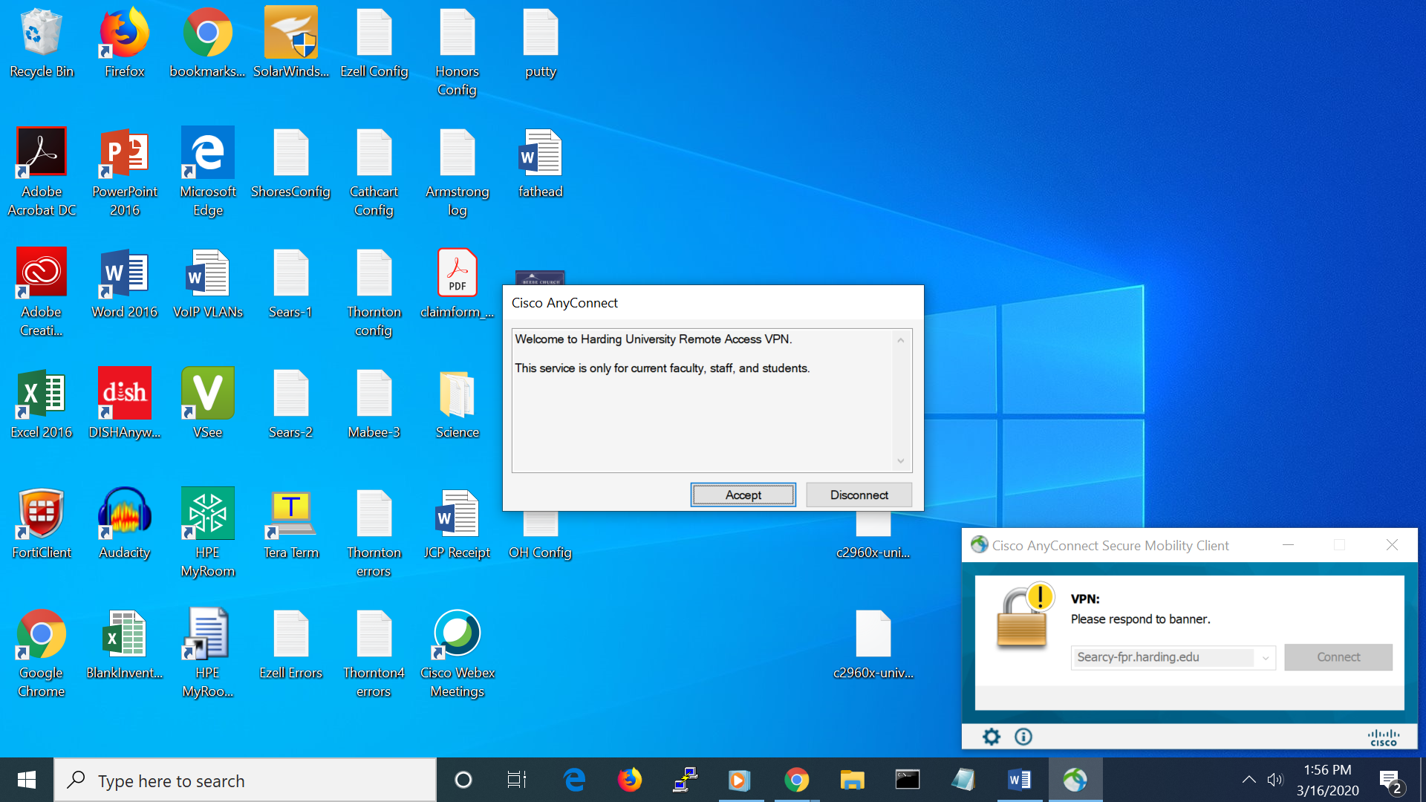

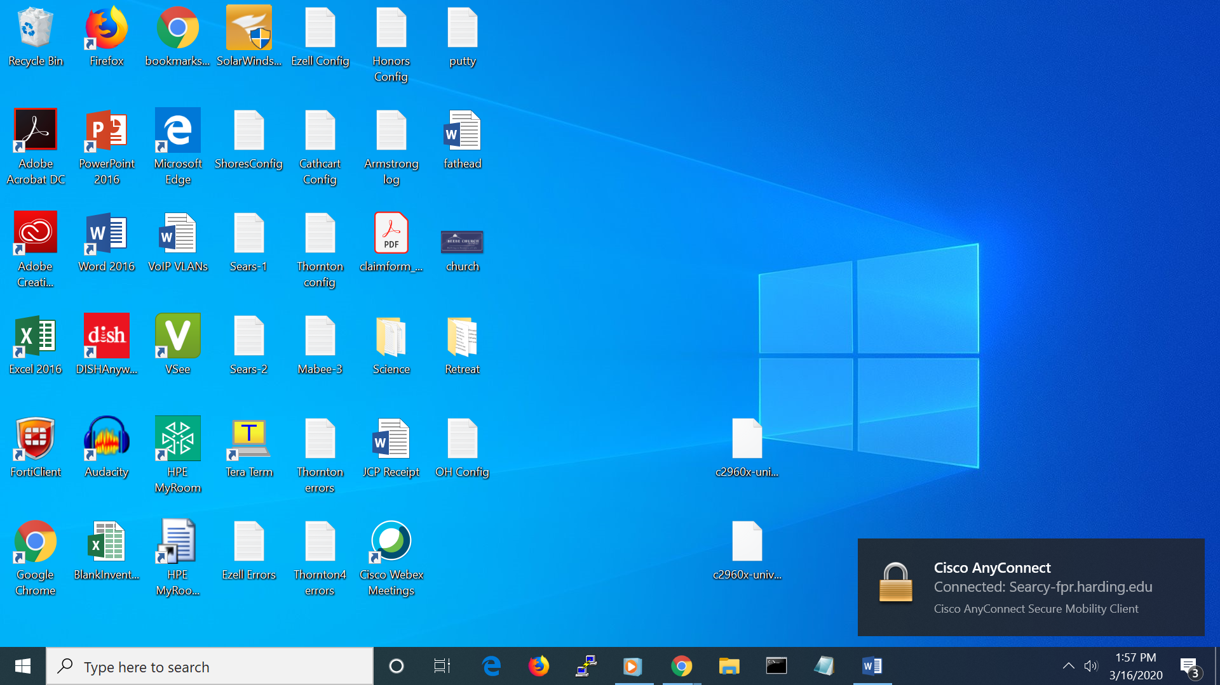9. Click Accept. When you see this last box, you are connected to the VPN. This allows your computer to behave as though it were on campus.